**Level 0 to 1:**

*Level Goal:*

The password for the next level is stored in a file called readme located in the home directory. Use this password to log into bandit1 using SSH. Whenever you find a password for a level, use SSH (on port 2220) to log into that level and continue the game.

*Commands used:*

ls – listing contents of the directory

cat – concatenate files and print on the standard output

exit – exiting the server

*Solution:*

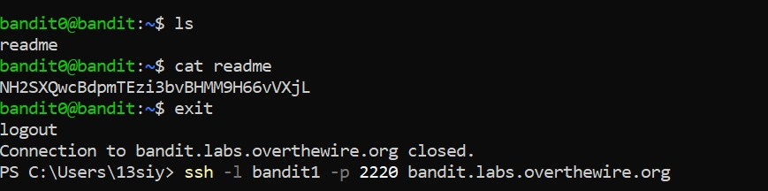

1. used ls to find the file ‘readme’.
2. used the command cat to find the password from the file readme.
3. exited the server and went to the next level

*Links used:*

<https://man7.org/linux/man-pages/man1/ls.1.html>

<https://man7.org/linux/man-pages/man1/cat.1.html>

**Level 1 to 2:**

*Level Goal:*

The password for the next level is stored in a file called – located in the home directory.

*Commands used:*

ls

cat

exit

*Solution:*

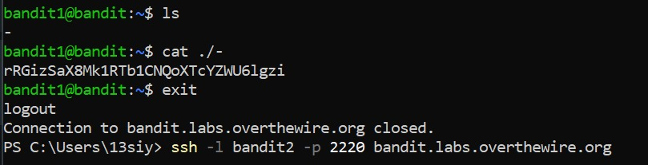

1. used ls to find the file named ‘-’.
2. used a specific case of cat with ./ to make sure that the filename is readable.
3. found the password and exited the server to go to the next level

*Links used:*

<https://stackoverflow.com/questions/42187323/how-to-open-a-dashed-filename-using-terminal>

**Level 2 to 3:**

*Level Goal:*

The password for the next level is stored in a file called **spaces in this filename** located in the home directory

*Commands used:*

ls

cat

exit

*Solution:*

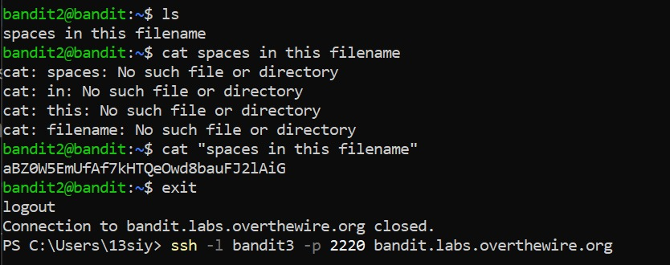

1. used ls to find the file ‘spaces in this filename’
2. tried to read the data in the file using regular cat command
3. read up on how to read file names with spaces and used quotations around the filename to find the password
4. exited the server to go to the next level

*Links used:*

<https://linuxhandbook.com/filename-spaces-linux/#:~:text=Read%20a%20file%20with%20spaces%20in%20filename&text=Basically%2C%20you%20put%20a%20%5C%20before,quotes%20instead%20of%20double%20quotes.&text=Single%20quotes%20ignore%20any%20special%20characters>.

**Level 3 to 4:**

*Level Goal:*

The password for the next level is stored in a hidden file in the **inhere** directory

*Commands used:*

ls

cd – change the working directory

cat

exit

*Solution:*

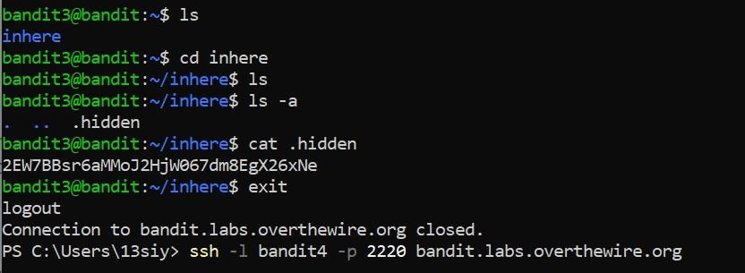

1. used ls to find the directory mentioned
2. used the cd command to enter the inhere directory
3. used ls again to get no output
4. looked into the ls manual to find the -a flag to view all files including hidden ones
5. the output arrives as ‘. .. .hidden’ and we can see .hidden is the file needed
6. use the command cat on that file and find the password
7. exit the server and access the next level

*Links used:*

<https://man7.org/linux/man-pages/man1/ls.1.html>

**Level 4 to 5:**

*Level Goal:*

The password for the next level is stored in the only human-readable file in the **inhere** directory. Tip: if your terminal is messed up, try the “reset” command.

*Commands used:*

ls

cd

cat

man – get a manual for the command in question

file – determine file type

reset – resets command window

exit

*Solution:*

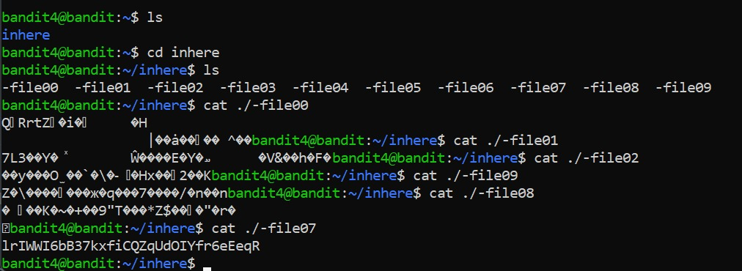

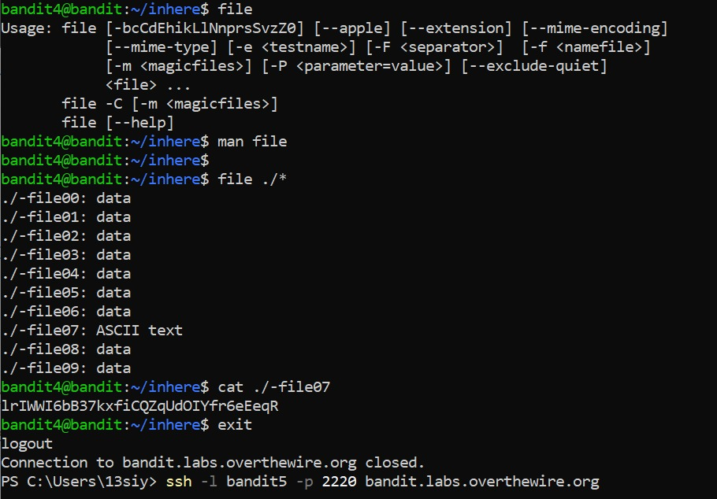

1. used ls to find the inhere directory and entered it
2. used ls within the directory to find 10 different files within it

*method 1:*

1. went through each individual files using cat ./<filenumber> from 0-2 and then backwards from 7-9
2. accidentally stumbled upon the password in file number 7
3. reset the system to try and find a more efficient way

*method 2:*

1. looked at a manual of file and used ./* to return the type of data stored in each file
2. file07 stored an ascii value and was the odd one out
3. used the cat command on file07 and found the password
4. exited the server and moved to the next level

*Links used:*

<https://www.javatpoint.com/linux-file?source=post_page-----72757d03001f-------------------------------->

**Level 5 to 6:**

*Level Goal:*

The password for the next level is stored in a file somewhere under the **inhere** directory and has all of the following properties:

* human-readable
* 1033 bytes in size
* not executable

*Commands used:*

ls

cd

cat

find – finds the file with the given flags/specifications

exit

*Solution:*

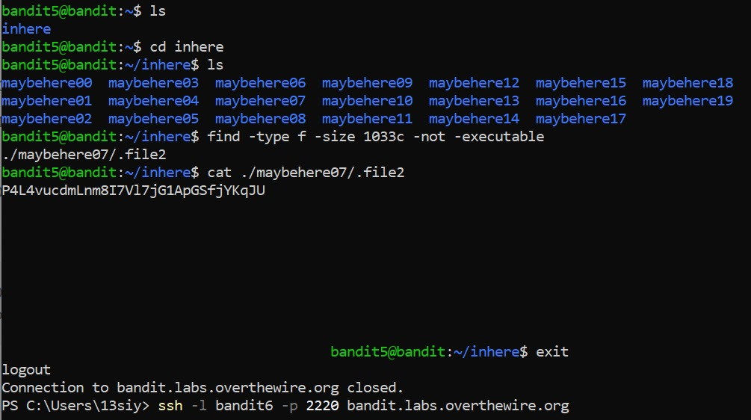

1. used ls command to find inhere directory
2. entered mentioned directory and used ls command again to find 18 directories
3. decided against using cat on individual directories as in the previous level and follow the limitations given in the question
4. find the file using the file command with the flags mentioned in the question after looking into the working of the find command
5. used the cat command on the file that showed up and found the password
6. exited the server and moved onto the next level

*Links used:*

<https://www.tecmint.com/35-practical-examples-of-linux-find-command/?source=post_page-----aa853b431c1d-------------------------------->

**Level 6 to 7:**

*Level Goal:*

The password for the next level is stored **somewhere on the server** and has all of the following properties:

* owned by user bandit7
* owned by group bandit6
* 33 bytes in size

*Commands used:*

ls

cat

find

exit

*Solution:*

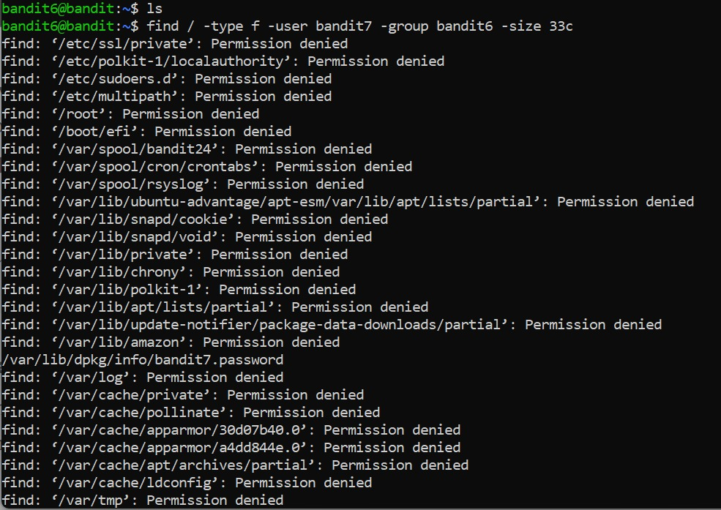

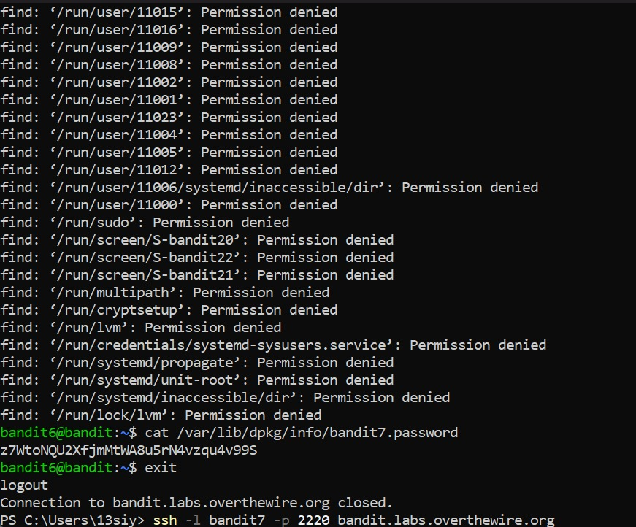

1. used ls command to get no output
2. used find with the given specifications to get a long list of files which I was denied permission to
3. while scrolling down it, realized that one of the files did not have a permission denied next to it
4. decided to concatenate that file and found the password
5. exited the server and accessed the next level

*Links used:* none

*Note:* want to know if there is a way to acquire only the file I have been given access to, rather than having to go through all the files and spot one by chance.

**Level 7 to 8:**

*Level Goal:*

The password for the next level is stored in the file data.txt next to the word millionth

*Commands used:*

ls

cat

grep - searches a file for a particular pattern of characters, and displays all lines that contain that pattern

exit

*Solution:*

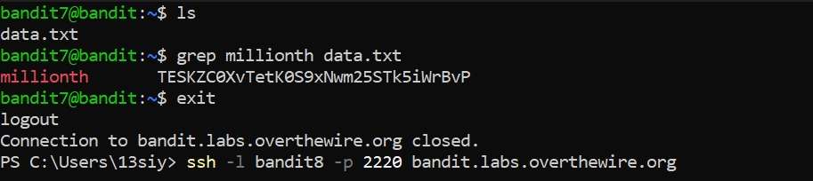

1. used the ls command to find the file data.txt and try to concatenate the file.
2. got a block of data so long it didn’t even allow me to enter commands into the server anymore
3. closed powershell and re-entered the server to try again
4. looked into the grep command since it was the second on the list of suggested commands
5. decided to use it with the word ‘millionth’ and the file data.txt
6. found the password and exited to access the next level

*Links used:*

<https://www.geeksforgeeks.org/grep-command-in-unixlinux/>

**Level 8 to 9:**

*Level Goal:*

The password for the next level is stored in the file **data.txt** and is the only line of text that occurs only once

*Commands used:*

ls

cat

uniq – reports or filters out the repeated lines in a file

sort – sorts the data given

exit

*Solution:*

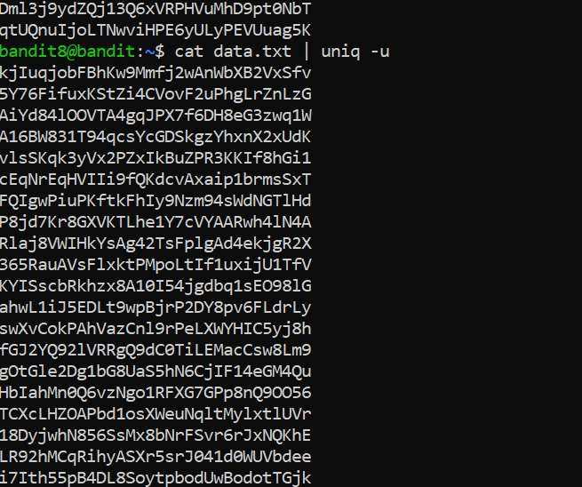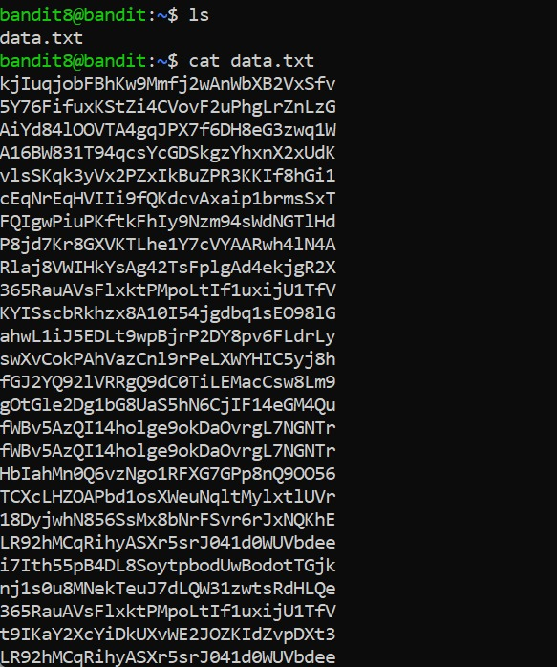

1. used the ls command to find the data.txt file and concatenated it
2. found a huge block of data
3. read up on the uniq utility and ran it as a part of the cat command, with the flag -u to find the unique line of data
4. got the same block of data (no noticeable difference)
5. re-read the function of uniq utility and realized that it only works on sorted data

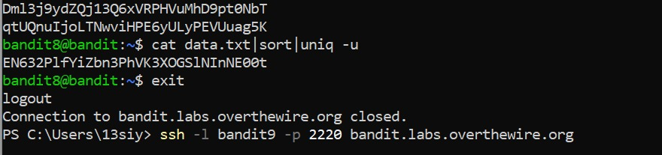

1. used the cat command with both the sort and uniq utilities (with -u flag) and found the password
2. exit the server and entered the next level

*Links used:*

<https://www.geeksforgeeks.org/uniq-command-in-linux-with-examples/>

**Level 9 to 10:**

*Level Goal:*

The password for the next level is stored in the file **data.txt** and is the only line of text that occurs only once

*Commands used:*

ls

cat

reset

grep

strings - return each string type of characters that are printable in the file

exit

*Solution:*

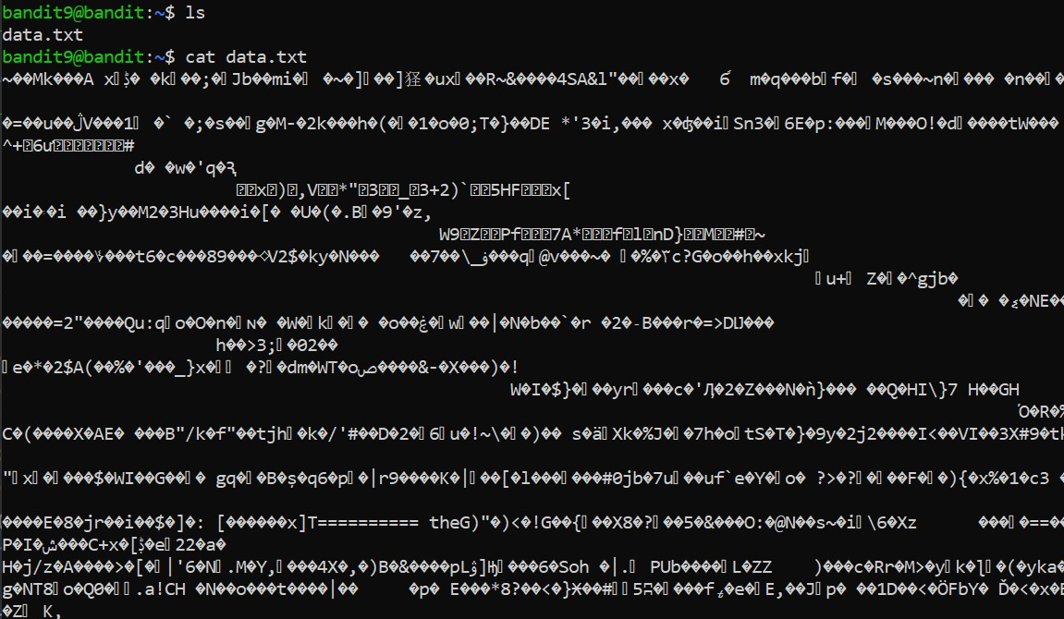

1. used ls and cat commands to no avail (encountered a block of text)

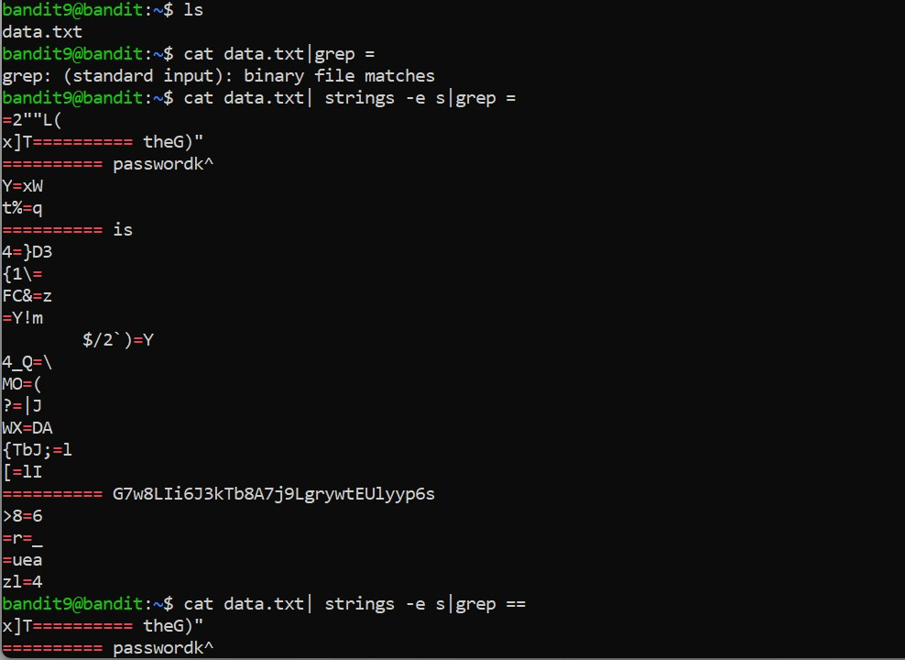

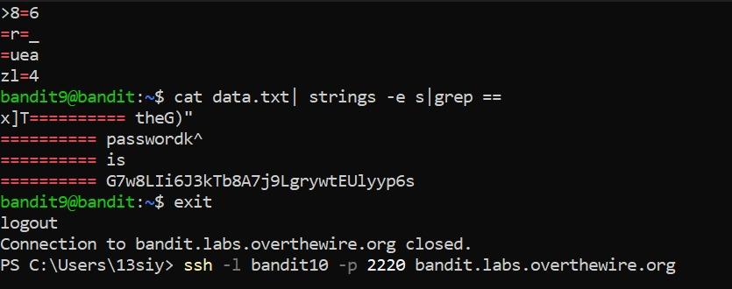

1. reset the window and re-entered the ls command
2. used the cat command with grep = as per the directive
3. got an error of some sort so read up on the strings utility that was on the list of suggested commands
4. decided to try it and entered it as a utility of the cat command alongside grep, using the flag -e as suggested in the second link given below (encoding)
5. got an output of a block of text but noticed the words password and something that appeared to be a correct flag next to a lot of ==’s
6. re-read the question and realized the password would be next to *several* =’s not one
7. re-entered the cat command as before and added an extra = to find the password
8. exited the server and accessed the next level

*Links used:*

<https://www.educba.com/linux-string-command/>

<https://www.tutorialspoint.com/unix_commands/strings.htm?source=post_page-----de8c95ce4efc-------------------------------->

**Level 10 to 11:**

*Level Goal:*

The password for the next level is stored in the file data.txt, which contains base64 encoded data

*Commands used:*

ls

cat

base64 - encodes binary strings into text representations using the base64 encoding format

exit

*Solution:*

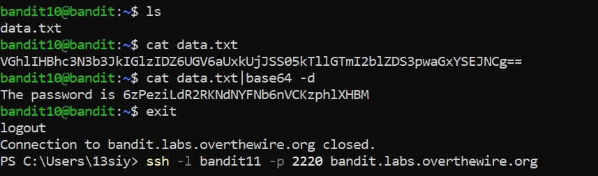

1. read up on the base64 command as it would be needed according to the question
2. used the ls command to find the data.txt file
3. used cat on it without base64 utility to see the output
4. used cat again with base64 along with the -d flag to decode the data given in the file
5. found the password and exited to access the next level

*Links used:*

<https://en.wikipedia.org/wiki/Base64>

<https://linuxhint.com/bash_base64_encode_decode/>

**Level 11 to 12:**

*Level Goal:*

The password for the next level is stored in the file data.txt, where all lowercase (a-z) and uppercase (A-Z) letters have been rotated by 13 positions

*Commands used:*

ls

cat

tr – used to translate/ transform data from one form to another

exit

*Solution:*

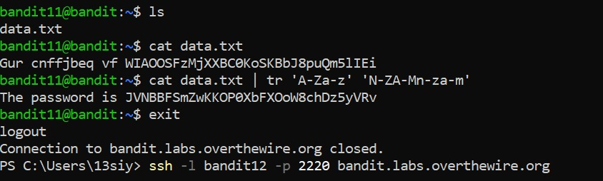

1. read up on rot13 and the tr command as it would be needed according to the question
2. used the ls command to find the data.txt file
3. used cat on it without tr utility to see the output
4. used cat again with tr along with the required inputs to get the password
5. exited the server

*Links used:*

<https://en.wikipedia.org/wiki/ROT13>

<https://linuxize.com/post/linux-tr-command/?source=post_page-----df6e59deda05-------------------------------->

**Level 12 to 13:**

*Level Goal:*

The password for the next level is stored in the file **data.txt**, which is a hexdump of a file that has been repeatedly compressed. For this level it may be useful to create a directory under /tmp in which you can work using mkdir. For example: mkdir /tmp/myname123. Then copy the datafile using cp, and rename it using mv (read the manpages!)

*Commands used:*

ls

cat

mkdir – make a directory

xxd – make a hexdump or convert hexdump to binary

file

gzip – compress or expand files

bzip2 – file compressor (block sorting)

cp – copy files and directories

mv – rename files

exit

*Solution:*

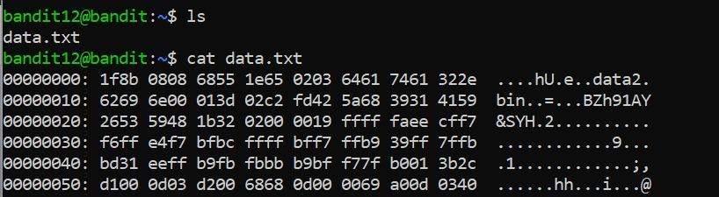

1. looked into the provided file using cat. tried to reverse hexdump the file given but did not have permission to do so
2. made a new directory named tmp/new_dir and copied all the data from the main directory into this one. then moved all the data from data.txt to a file named ‘data’.

bandit12@bandit:/tmp/new_dir$ cp ~/data.txt

bandit12@bandit:/tmp/new_dir$ ls

data.txt

bandit12@bandit:/tmp/new_dir$ mv data.txt data

bandit12@bandit:/tmp/new_dir$ ls  
 data

1. it started getting too messy so I reset the server and exited in the hopes of trying again and remaking a new directory (which is why there is no screenshot of the above commands since I forgot reset would make all of it disappear)
2. unfortunately, got the output ‘cannot create directory: file exists’ on both my names (random and random_dir) so I decided to try and enter a dir i already knew existed (new_dir) 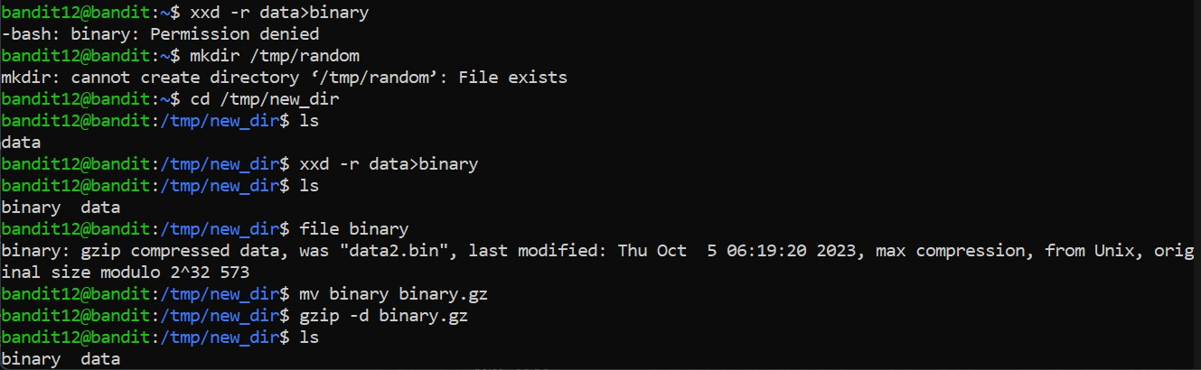
3. used cd to enter the new directory new_dir and look at the file there (data). then used the xxd command on it, but added a flag -r to make sure it understood to convert the data to binary
4. when we look into the directory again we can see two files now: data and binary
5. decided to look at binary, used file command, which told me that binary was gzipped. changed the file extension to fit the requirements to unzip it (changed the suffix to .gz), and used the gzip command with -d flag to decode it.
6. check on the binary file again and this time it’s a bzip2 of compressed data. decoded that directly which led to another gzip file

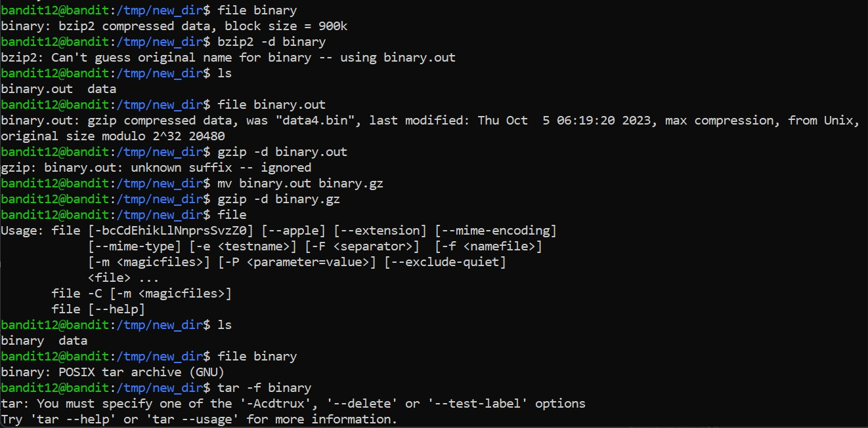

1. repeated steps 7 and 8, along with the tar command with the -xf flag, to keep breaking into the zipped files until finally we get the output ‘data8.bin: ASCII text’.

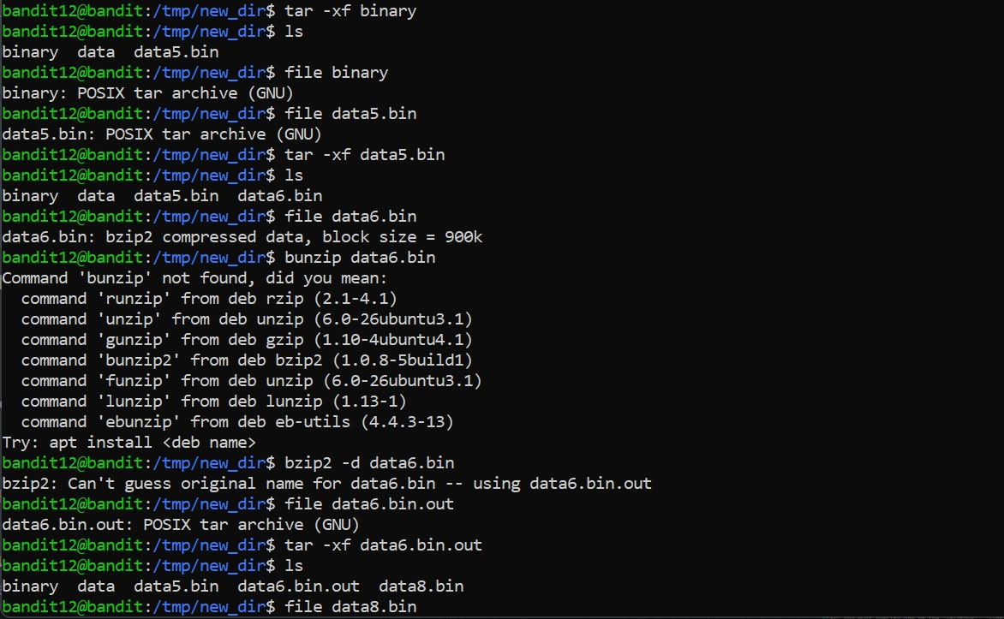

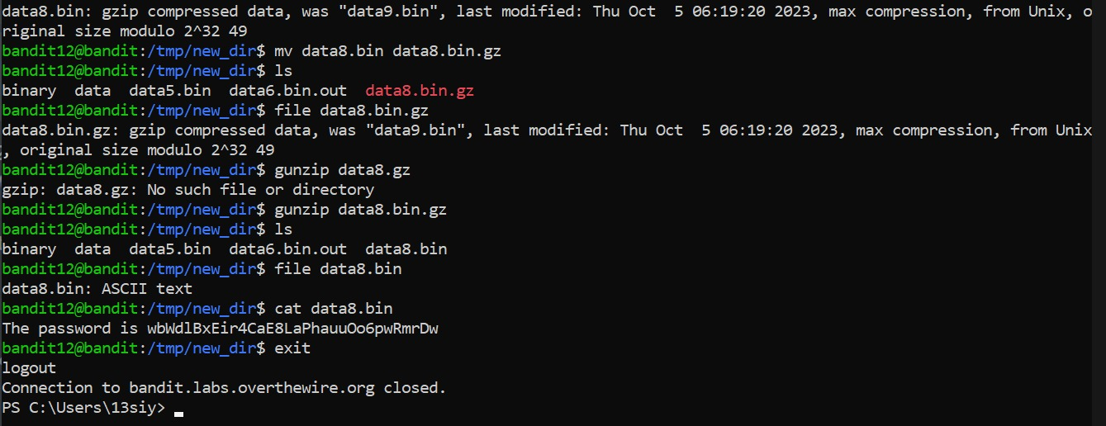

1. cat data8.bin to find the password required, exit and log onto the next level

*Links used:*

<https://linuxize.com/post/gzip-command-in-linux/?source=post_page-----2ec761a88907-------------------------------->

<https://linuxize.com/post/how-to-create-and-extract-archives-using-the-tar-command-in-linux/?source=post_page-----2ec761a88907-------------------------------->

**Level 13 to 14:**

*Level Goal:*

The password for the next level is stored in **/etc/bandit_pass/bandit14 and can only be read by user bandit14**. For this level, you don’t get the next password, but you get a private SSH key that can be used to log into the next level. **Note:** **localhost** is a hostname that refers to the machine you are working on

*Commands used:*

ls

ssh – OpenSSH remote login client

exit

*Solution:*

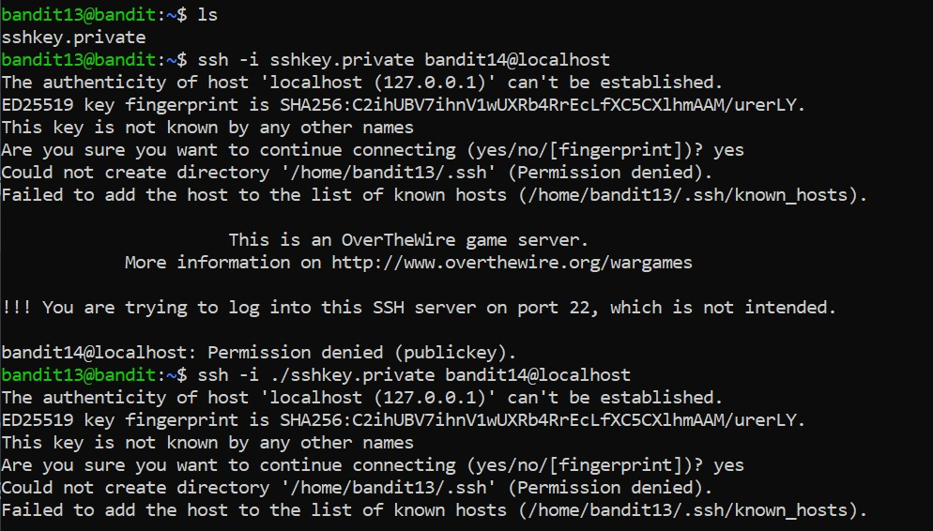

1. looked into the server and found the key to access the next level
2. tried to log into the next server using the ssh command to no avail, twice, both using the flag -i to recognize the name of the key
3. finally got it by adding the port number 2220 to the command and entered the next level

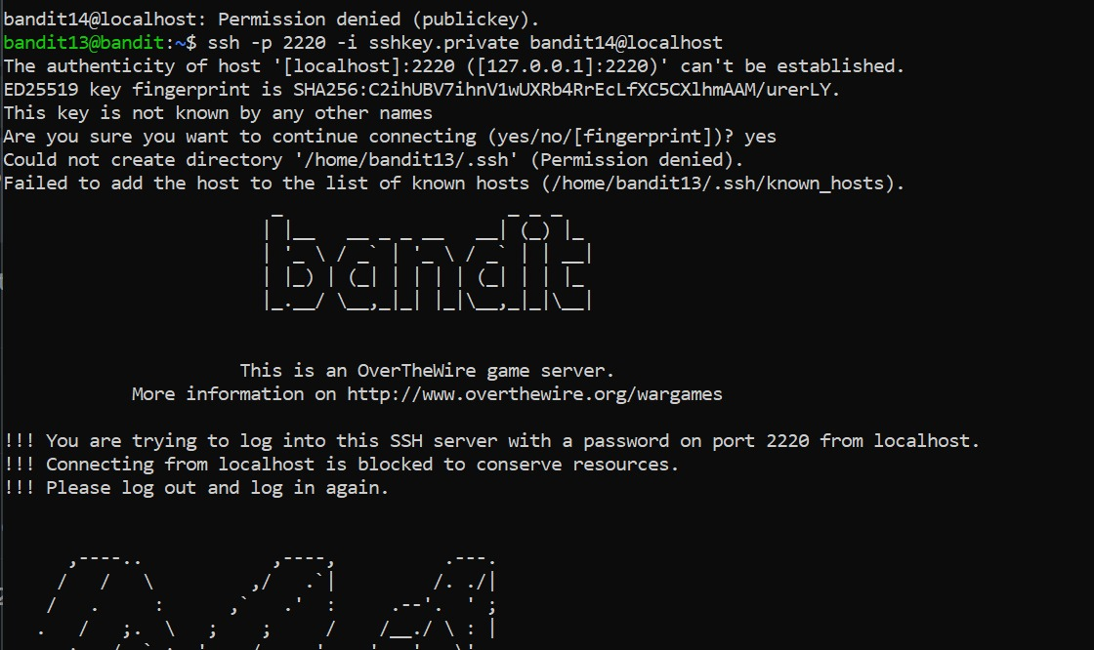

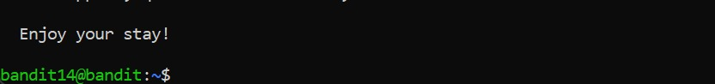

*Links used:*

<https://help.ubuntu.com/community/SSH/OpenSSH/Keys>

**Level 14 to 15:**

*Level Goal:*

The password for the next level can be retrieved by submitting the password of the current level to **port 30000 on localhost**.

*Commands used:*

ls

cat

nc – TCP/IP swiss army knife

exit

*Solution:*

1. used the cat command to see what is in the file mentioned, found the password to enter level 14.
2. opened a manual on nc to find out how to add the port key to connect to the service
3. successfully connected to the service but accidentally pressed the enter button and got a ‘Wrong!’ message.
4. Entered the correct password and found the password for the next level, and exited the current level

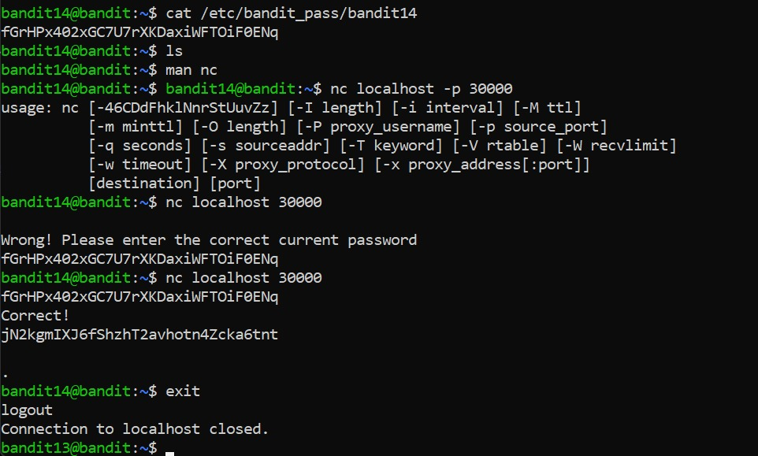

*Links used:*

<https://linuxize.com/post/netcat-nc-command-with-examples/?source=post_page-----9f0fd934a9bc-------------------------------->

**Level 15 to 16:**

*Level Goal:*

The password for the next level can be retrieved by submitting the password of the current level to **port 30001 on localhost** using SSL encryption

*Commands used:*

ls

cat

nc – TCP/IP swiss army knife

exit

*Solution:*

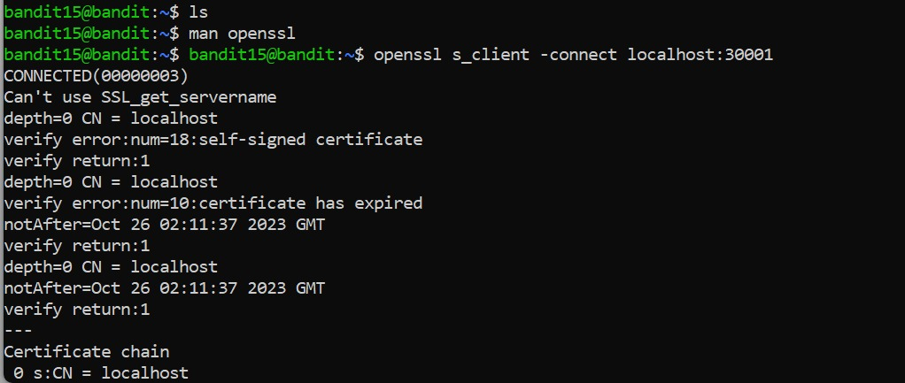

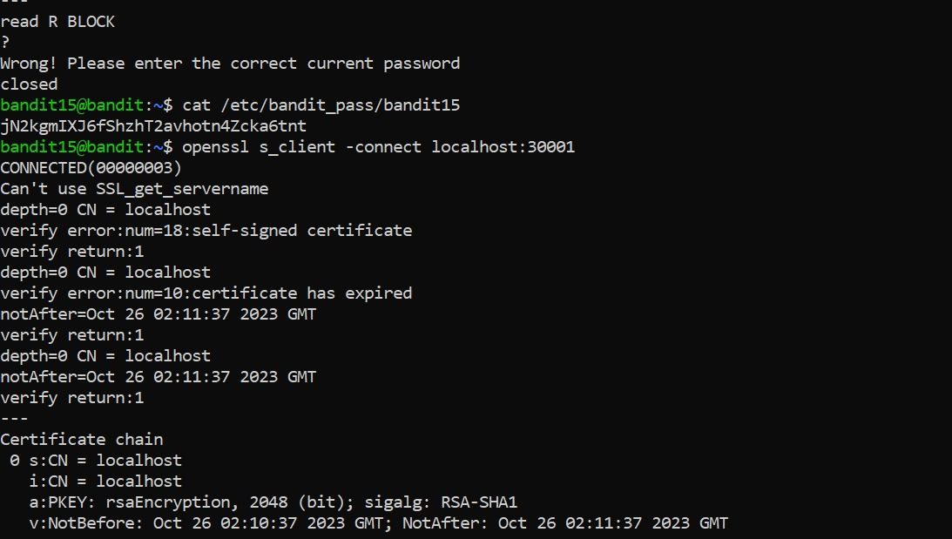

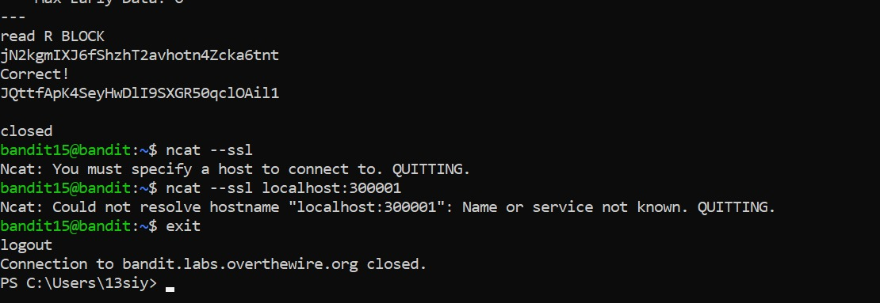

1. used ls to no output then opened a manual on openssl, used the connect flag to connect to the port given in the question
2. got an output with no instructions so entered a question mark to see the result
3. output was ‘Wrong! Enter the correct password’ and hence, decided to try the same thing as last level
4. got the correct password by rereading the file /etc/bandit_pass/bandit15
5. retried step 1, and this time entered the password and got the password for the next level.
6. Tried a different method using ncat --ssl which did not work (which I now see is because I was entering the wrong port), so decided to just exit out of the server

*Links used:*

<https://en.wikipedia.org/wiki/Transport_Layer_Security#SSL_1.0,_2.0,_and_3.0>

**Level 16 to 17:**

*Level Goal:*

The credentials for the next level can be retrieved by submitting the password of the current level to **a port on localhost in the range 31000 to 32000**. First find out which of these ports have a server listening on them. Then find out which of those speak SSL and which don’t. There is only 1 server that will give the next credentials, the others will simply send back to you whatever you send to it.

*Commands used:*

ls

cat

touch – tested a name to see if the file or folder is empty

nmap - network exploration tool and security / port scanner

ssh

openssl – openssl command line tool

s_client – tls client program

exit

*Solution:*

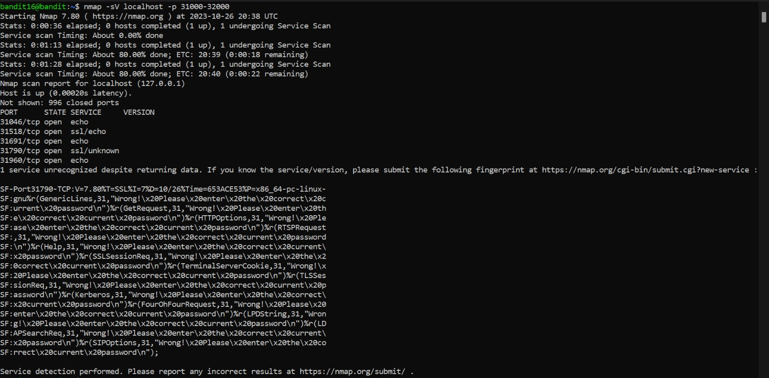

1. the service that we need is running in the range 31,000–32,000, we can find all services in that range using nmap command with the -p flag is used to specify the ports and the -sV flag to identify the versions of the services
2. if we look at the results more closely, we see that on port 31790 is specified outside the “wrong! Please enter the correct passwords!”
3. using openssl and s_client with the connect flag to connect to localhost:31790, and entered the password that I used to enter into this level
4. here we get an RSA private key. decided to look up how to use RSA keys and found out you can use both vim and nano to copy rsa private keys, and store them in a file
5. touched a tmp directory to see if I could cd into it, and proceeded to enter into it to store the key into a file ‘private.key’ using nano command.

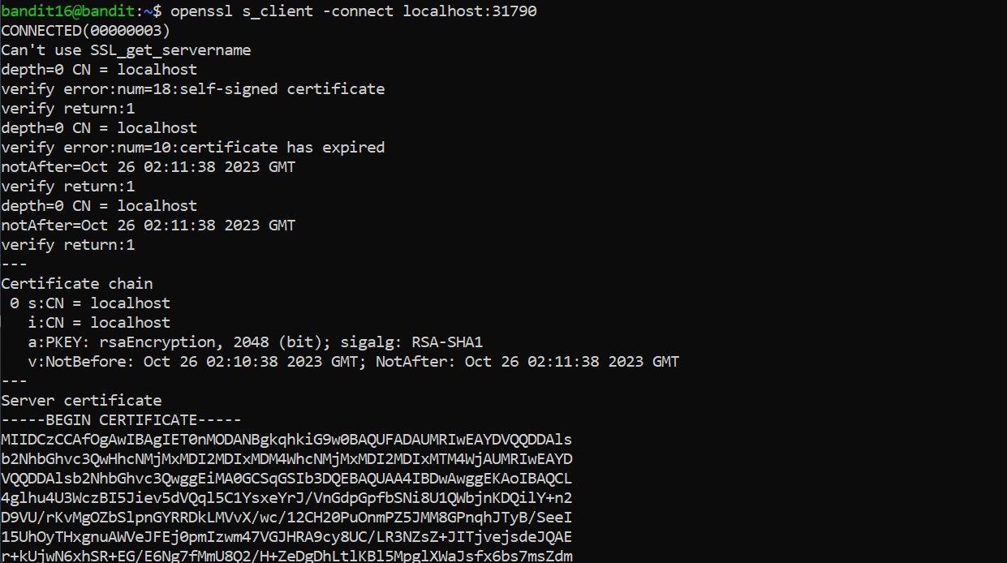

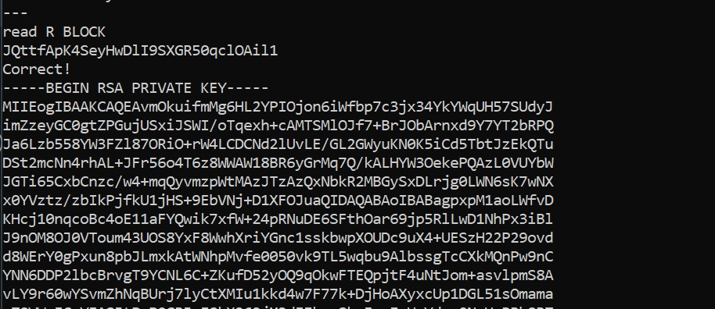

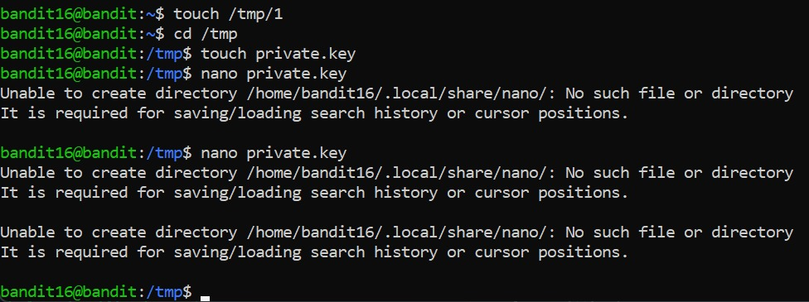

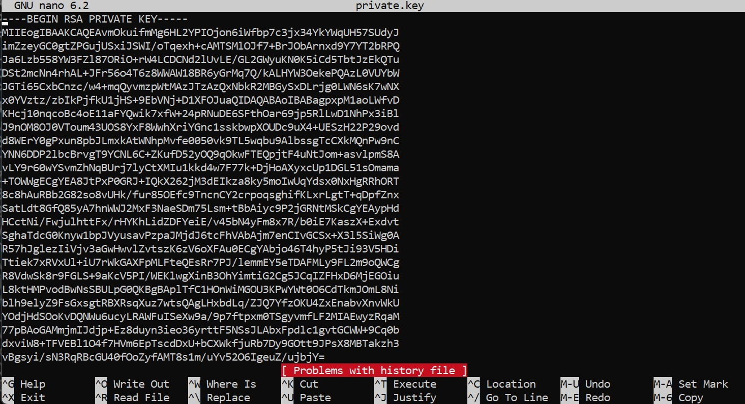

1. used the ls command with -l flag to look at the permissions of the file since that proved to be a problem before in a previous level, changed the permissions to 400 to make it less public
2. unfortunately, this key did not work and I tried to do the same thing over and over (did not take screenshot as it was all futile attempts with no avail.)
3. looked at every single walkthrough I could find and still did not realize what I was doing wrong

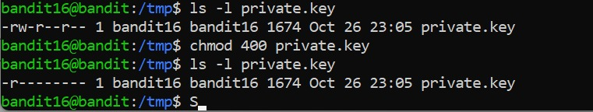

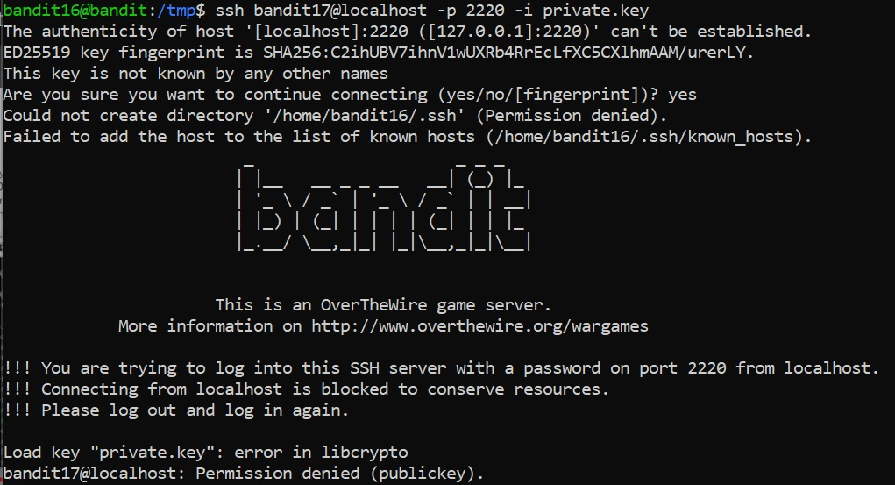

1. tried again the next day, this time by changing the permissions to 600 instead of 400 or 700 like I was trying before
2. this finally worked and I was able to log into the bandit17 server and get the password using cat /etc/bandit_pass/bandit17

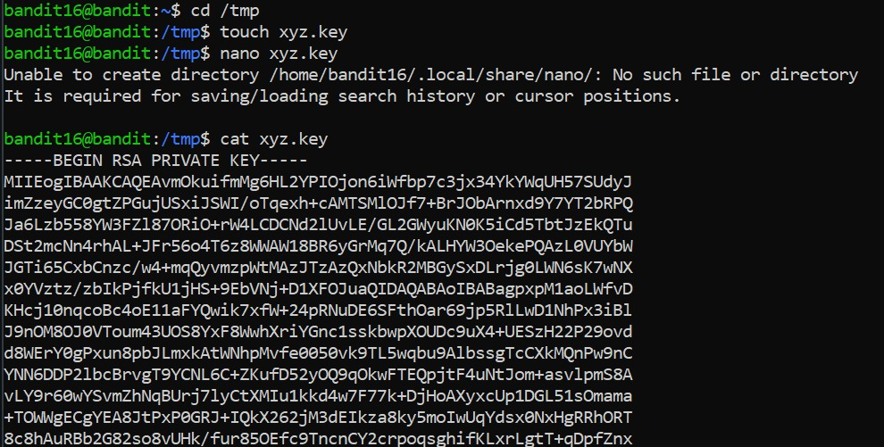

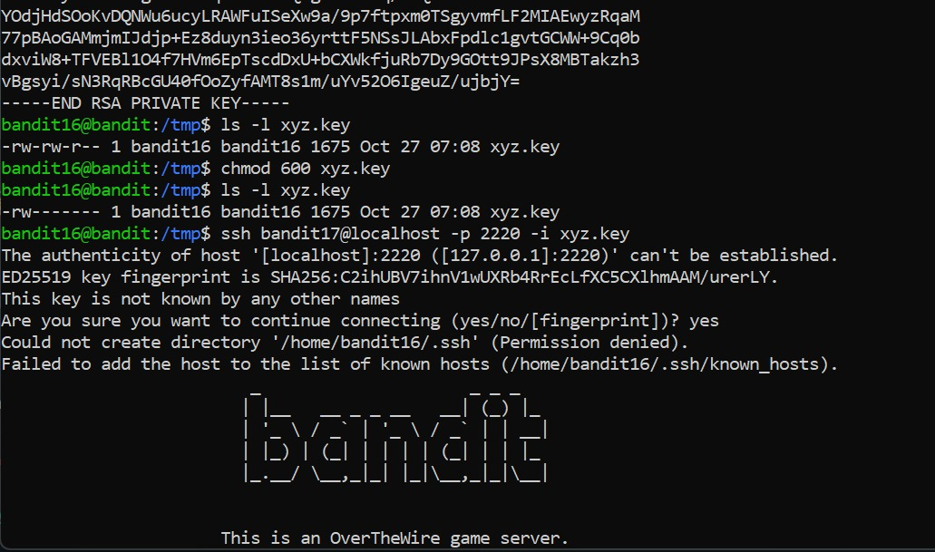

*Links used:*

<https://youtu.be/CQ14LbpQofQ?si=P7MfWw7ADitZ4udo>

<https://stackoverflow.com/questions/75935815/stuck-on-16-17-level-of-overthewire-bandit-game>

<https://en.wikipedia.org/wiki/Port_scanner>

<https://www.ssldragon.com/blog/what-is-openssl/>

<https://www.geeksforgeeks.org/practical-uses-of-openssl-command-in-linux/>

<https://www.geeksforgeeks.org/nmap-command-in-linux-with-examples/>

<https://www.openssl.org/docs/man1.1.1/man1/openssl-s_client.html#:~:text=The%20s_client%20command%20implements%20a,diagnostic%20tool%20for%20SSL%20servers>

**Level 17 to 18:**

*Level Goal:*

There are 2 files in the home directory: **passwords.old and passwords.new**. The password for the next level is in **passwords.new** and is the only line that has been changed between **passwords.old and passwords.new**

*Commands used:*

ls

cat

diff – compares text files

exit

*Solution:*

1. used cat to get the password for the level similar to level 15.
2. used ls to see the files in directory
3. looked into one of the files using cat and found a block of text

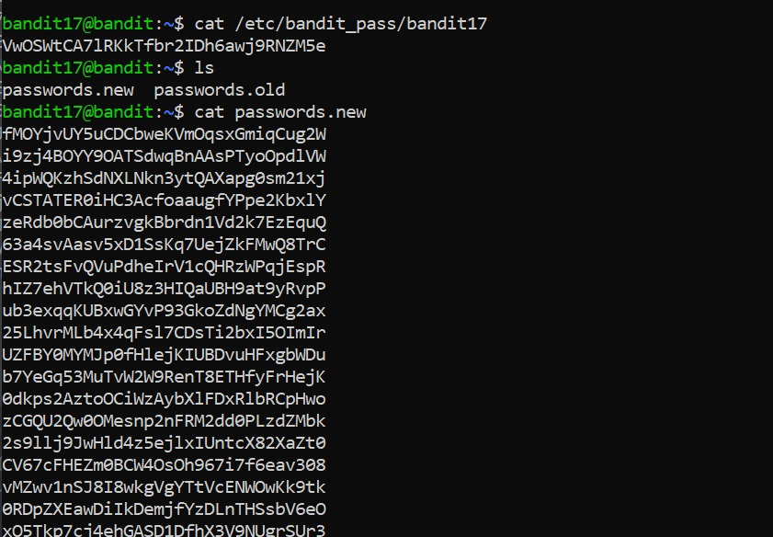

1. looked up how to figure out what’s the difference between two files, found the diff command
2. used the diff command to find the two differences in the file
3. stored both the files in my notepad but used only the ‘passwords.new’ password to log onto the next level according to the question

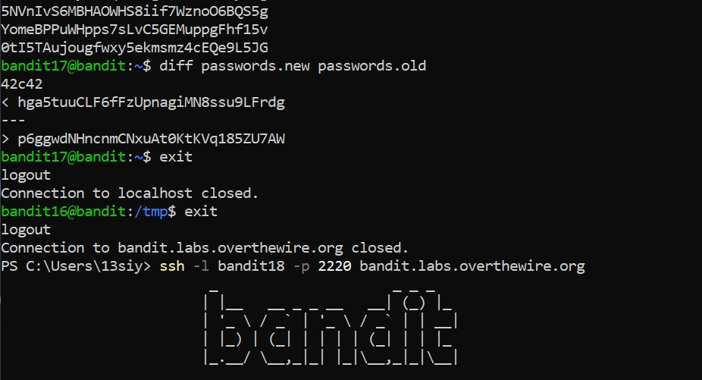

*Links used:*

<https://www.ibm.com/docs/en/aix/7.2?topic=files-comparing-diff-command>

**Level 18 to 19:**

*Level Goal:*

The password for the next level is stored in a file **readme** in the home directory. Unfortunately, someone has modified **.bashrc** to log you out when you log in with SSH.

*Commands used:*

ls

cat

diff – compares text files

exit

*Solution:*

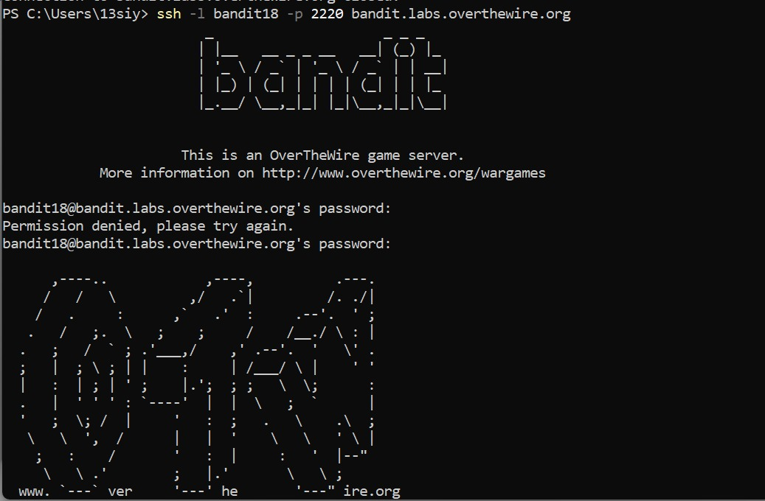

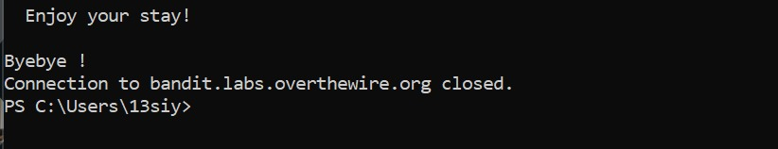

Method 1:

1. saw that I can’t log onto the localhost even with the right password
2. decided to look up how to circumvent the problem
3. decided to execute commands within the ssh command
4. used ls within the ssh command and found the readme file
5. used cat readme within the ssh command once more and found the password

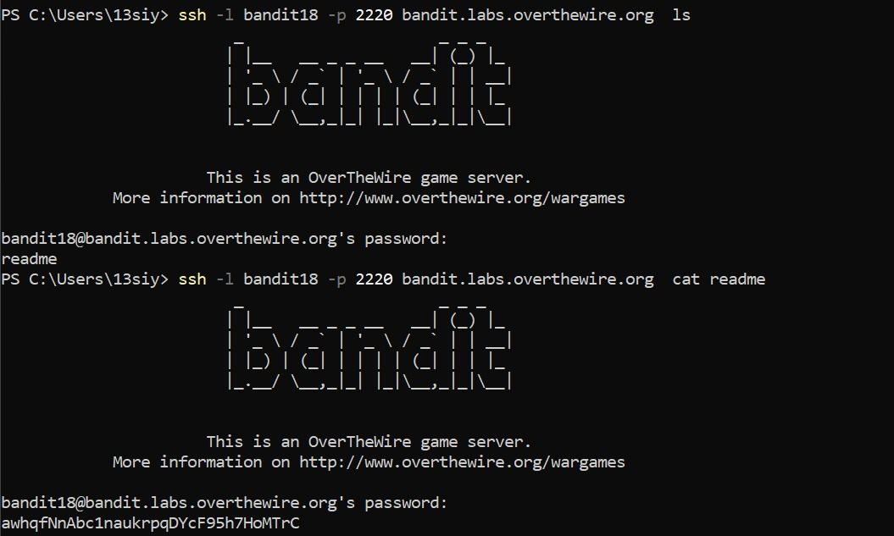

Method 2:

1. while looking up ways to circumvent the problem, realized that I could also use a preset shell to log into the server, with a -t flag to specify that the shell will be used to log into the server
2. decided to use the /bin/sh shell since that was the one that seemed most common in the details of all the shells stored in linux
3. further, used ls and cat after successfully logging into the server to find the password and exited the server

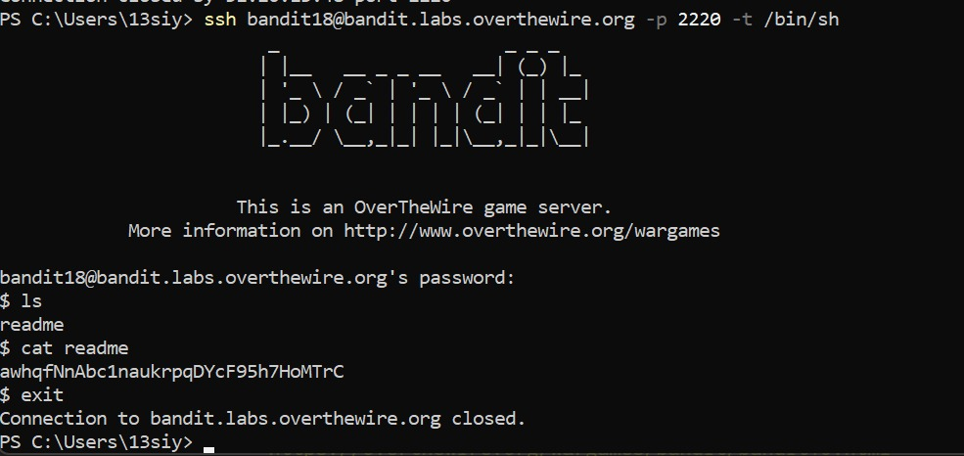

*Links used:*

<https://www.cyberciti.biz/faq/unix-linux-execute-command-using-ssh/>

<https://serverfault.com/questions/162018/force-ssh-to-use-a-specific-shell>

<https://medium.com/@JAlblas/tryhackme-what-the-shell-walkthrough-6c0ebe8f854e>

**List of passwords**

level 0 password: NH2SXQwcBdpmTEzi3bvBHMM9H66vVXjL

level 1: rRGizSaX8Mk1RTb1CNQoXTcYZWU6lgzi

level 2: aBZ0W5EmUfAf7kHTQeOwd8bauFJ2lAiG

level 3: 2EW7BBsr6aMMoJ2HjW067dm8EgX26xNe

level 4: lrIWWI6bB37kxfiCQZqUdOIYfr6eEeqR

level 5: P4L4vucdmLnm8I7Vl7jG1ApGSfjYKqJU

level 6: z7WtoNQU2XfjmMtWA8u5rN4vzqu4v99S

level 7: TESKZC0XvTetK0S9xNwm25STk5iWrBvP

level 8: EN632PlfYiZbn3PhVK3XOGSlNInNE00t

level 9: G7w8LIi6J3kTb8A7j9LgrywtEUlyyp6s

level 10: 6zPeziLdR2RKNdNYFNb6nVCKzphlXHBM

level 11: JVNBBFSmZwKKOP0XbFXOoW8chDz5yVRv

level 12: wbWdlBxEir4CaE8LaPhauuOo6pwRmrDw

level 13: fGrHPx402xGC7U7rXKDaxiWFTOiF0ENq

level 14: jN2kgmIXJ6fShzhT2avhotn4Zcka6tnt

level 15: JQttfApK4SeyHwDlI9SXGR50qclOAil1

level 16: VwOSWtCA7lRKkTfbr2IDh6awj9RNZM5e

level 17: hga5tuuCLF6fFzUpnagiMN8ssu9LFrdg p6ggwdNHncnmCNxuAt0KtKVq185ZU7AW

level 18: awhqfNnAbc1naukrpqDYcF95h7HoMTrC